CSE 581

**Lab 14: Error Handling**

*Do this against YOUR own database.*

***For the entire lab, provide all of your SQL as text, inserted at the beginning of the document.***

***For each step also provide a screenshot of execution, showing the SQL and the results.***

***Please make sure both the SQL and the screenshots are marked w/ the question number that they are answering.***

**Steps:**

1. Create a stored procedure: The SP should accept (for input) 2 parameters (let’s say A and B) and returns the result of A divided by B (in some way). The SP should do error handling[1], and if an error occurs, it should print out *“An error has occurred”* and ***return*** -1 as a result.

CREATE PROCEDURE dbo.ErrorHandling (@A as INT, @B as INT, @Result as decimal(3,1) out)

as

BEGIN TRY

SET @Result = @A/@B

END TRY

BEGIN CATCH

PRINT'An error has occurred'

SET @Result = -1

END CATCH;

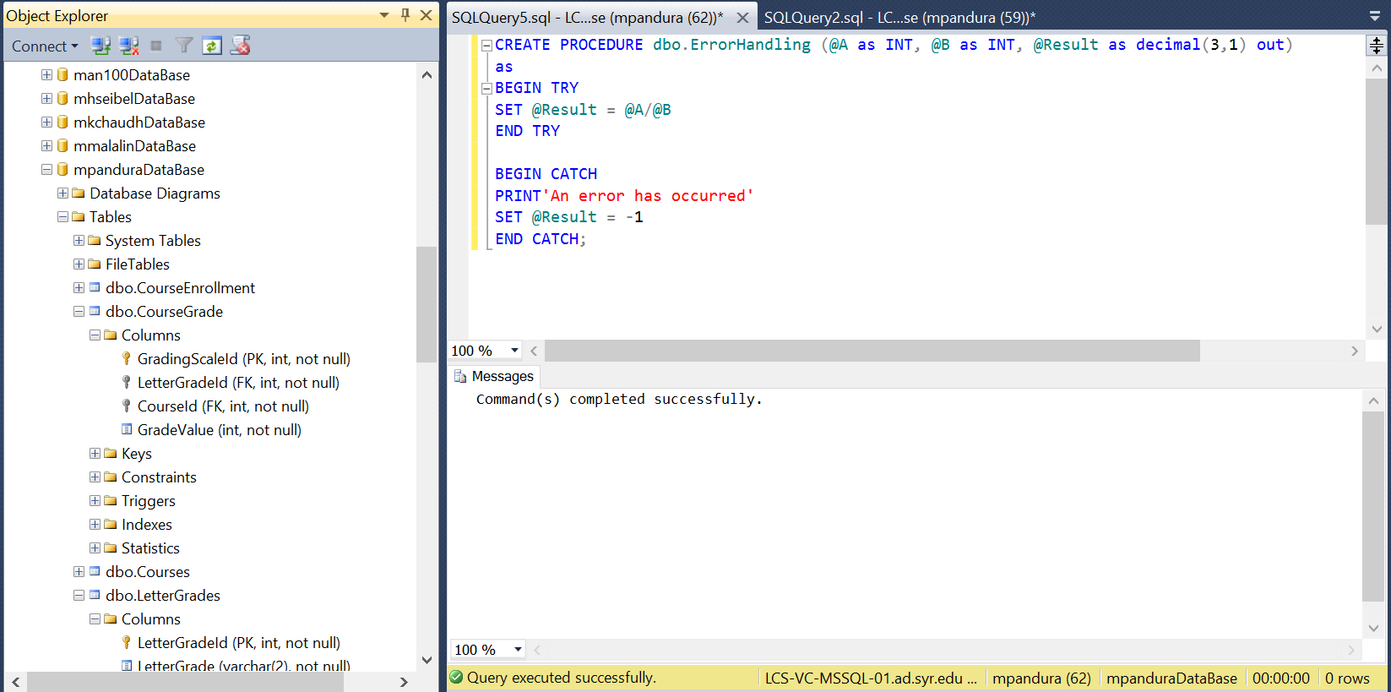

1. Execute the SP with input A = 10, B = 2. Verify that the result and error message are as expected.

DECLARE @Result decimal(3,1);

EXEC dbo.ErrorHandling 10, 2, @Result OUT;

PRINT @Result;

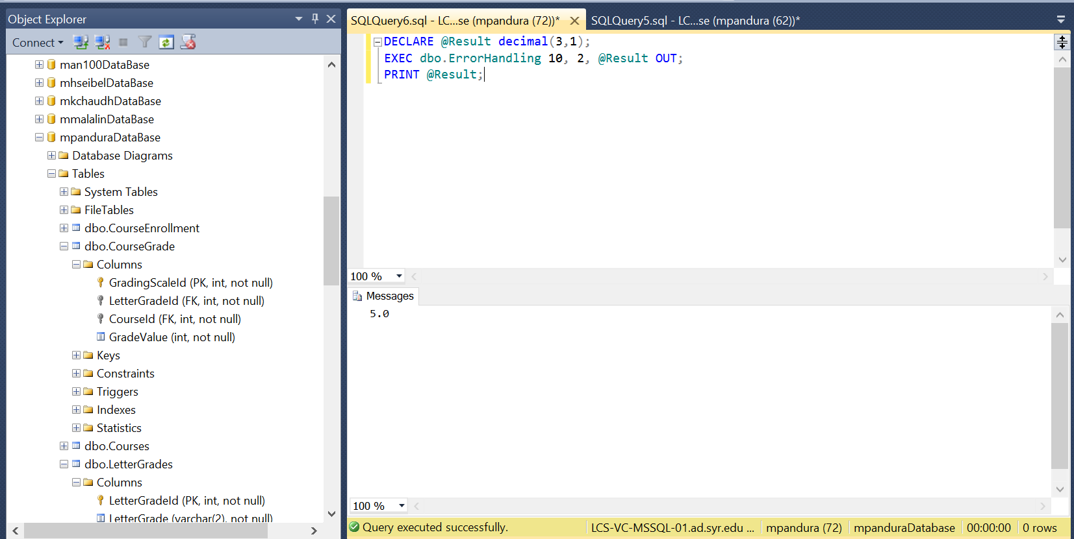

1. Execute the SP with input A = 10, B = 0. Verify that the result and error message are as expected.

DECLARE @Result decimal(3,1);

EXEC dbo.ErrorHandling 10, 0, @Result OUT;

PRINT @Result;

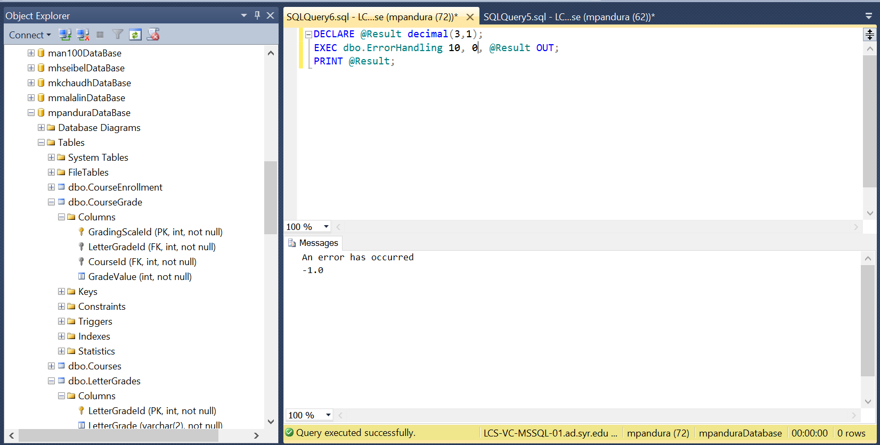

1. I would recommend using the TRY/CATCH block